Insert “to” where necessary:
1) Parents usually expect their children ____ be obedient.
2) The inspector would like you ____ explain everything to him.
3) He wanted his students ____ learn the poem by heart.
4) We believe it ____ be the best way out of this situation.
5) People knew him ____ be a great scientist.
6) She thought him ____ be a thief, but he wasn’t.
7) Jane made me ____ tell her all the truth.
8) When I was young, my parents didn’t let me ____ eat much ice-cream.
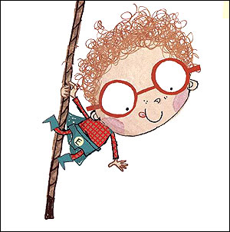
9) This girl would like you ____ invite her to dance.
10) We heard the car ____ stop in front of our house.
11) We expected them ____ come in two day.
12) I am always made ____ do my bed in the morning.
13) Do you want me ____ open the window?
14) I’m not allowed ____ watch this horror film.
15) The teacher made me ____ do this work again.
16) Let me ____ do it.
17) I want my girlfriend ____ call me.
18) I was made ____ speak in front of the whole class.
19) I want my granny ____ take me to the circus.
20) The guide let us ____ climb the mountain.
21) She would like her children ____ go to the dentist every six months.
22) Every teacher asks the students ____ do their homework.
23) Tina doesn’t let me ____ kiss her.

