- We use used to when we describe a habit in the past
- We often use used to to contrast a past habit with what we do now
- The past simple is also possible but used to is more common

Statements: I used to play tennis when I was a teenager

Negatives: I didn’t use to play basketball when i studied at school

Question: Did you use to play football when you were little?

A. Rewrite each sentence with used to

- I was in the school swimming team ______________________________________________________________________
- Sophie had long hair when she was 7 ______________________________________________________________________
- Mary didn’t listen when her teachers were speaking ______________________________________________________________________
- Ricardo got up at 6:00 when he was training for the Olympics ______________________________________________________________________
- What did you usually do on Saturday evening? ______________________________________________________________________
- My brother wore glasses when he was small ______________________________________________________________________
- Becky was afraid of dogs when she was a little girl ______________________________________________________________________
- We always gave our teacher presents at the end of the term ______________________________________________________________________
- Paul has spoken Italian well but he has forgotten it ______________________________________________________________________
- Did you live next door to Mrs Harrison? ______________________________________________________________________

- Complete the personal details

- I used to drink ............................................................................... but now I don’t
- I used to live in ............................................................................... but now I don’t
- I used to go to ............................................................................... but now I don’t
- I used to play with ...........................................................................but now I don’t
- I used to read ............................................................................... but now I don’t
- I used to watch ...............................................................................but now I don’t
- I used to listen ............................................................................... but now I don’t
- I used to get up at ............................................................................but now I don’t
- I used to go to bed at .......................................................................but now I don’t
- I used to sit next to ...................................................................... but now I don’t
- I used to love ............................................................................... but now I don’t
- I used to hate ............................................................................... but now I don’t

- Discuss the following pictures

- Mark
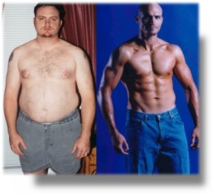

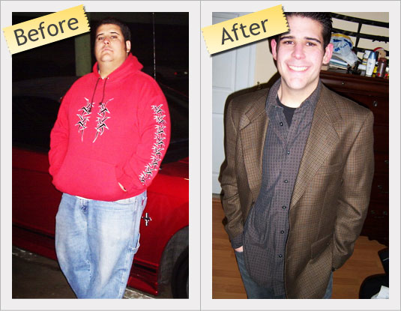
b. David

